**Practice on Clustering**

**Hierarchical clustering for first six points**

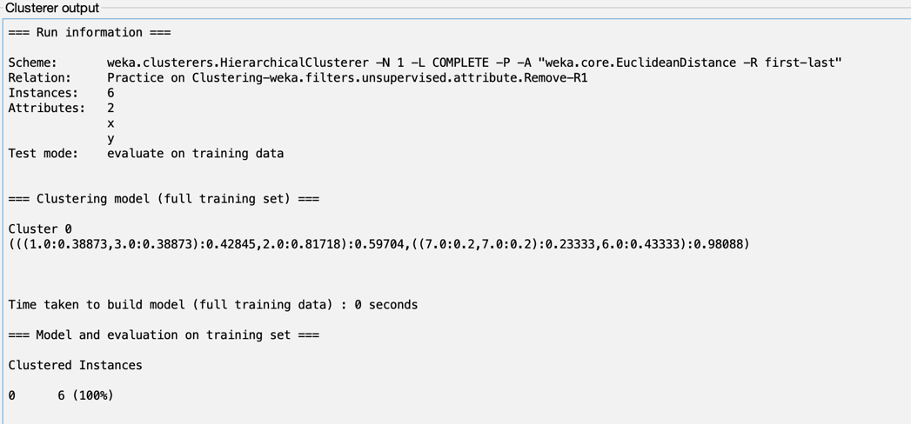

**Cluster assignments for first six points**

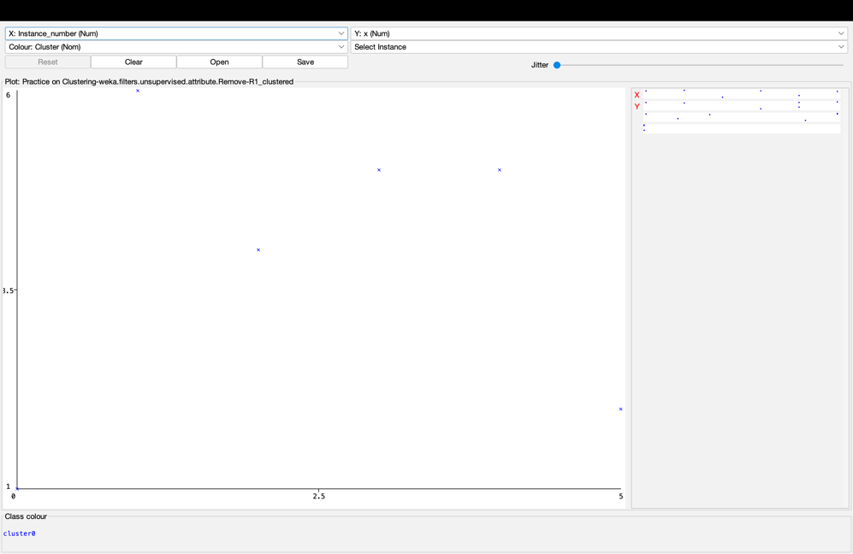

**Tree for first six points**

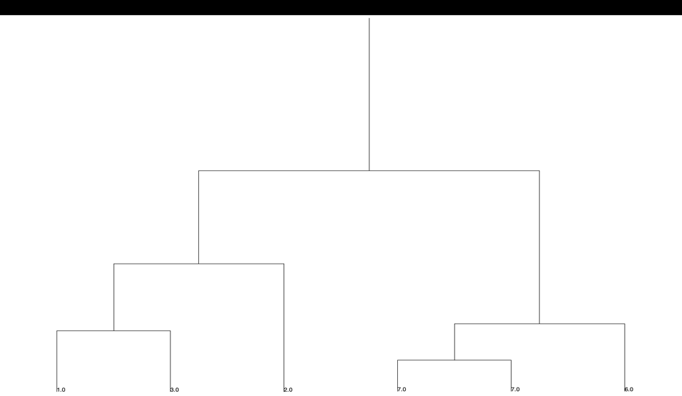

**Laboratory Questions**

**Hierarchical clustering for single link**

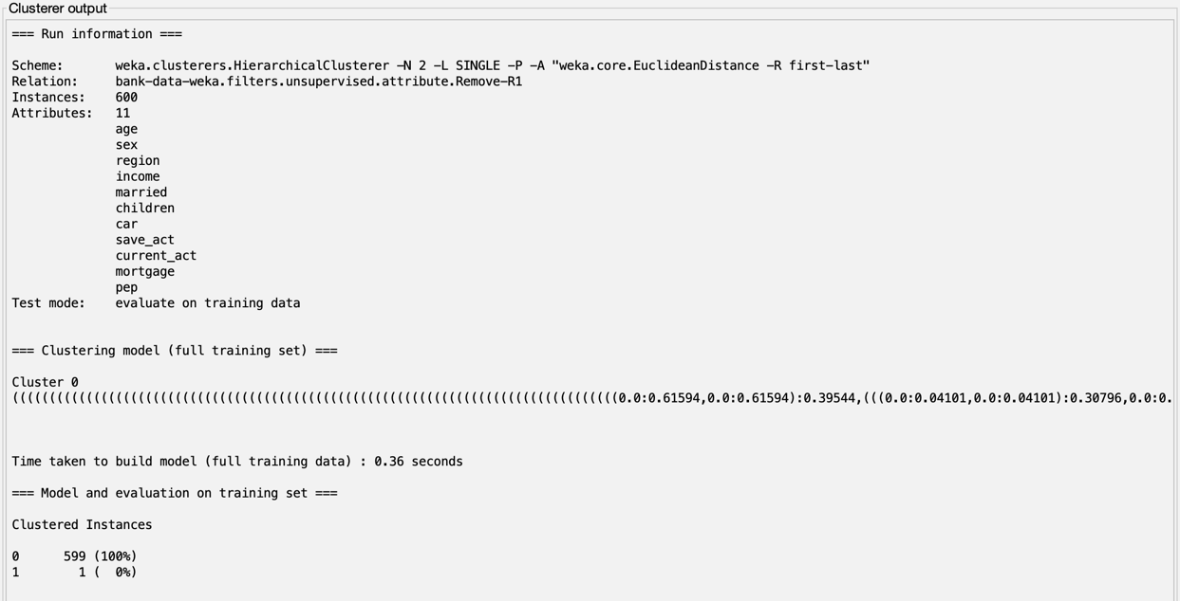

**Tree for Hierarchical clustering for single link**

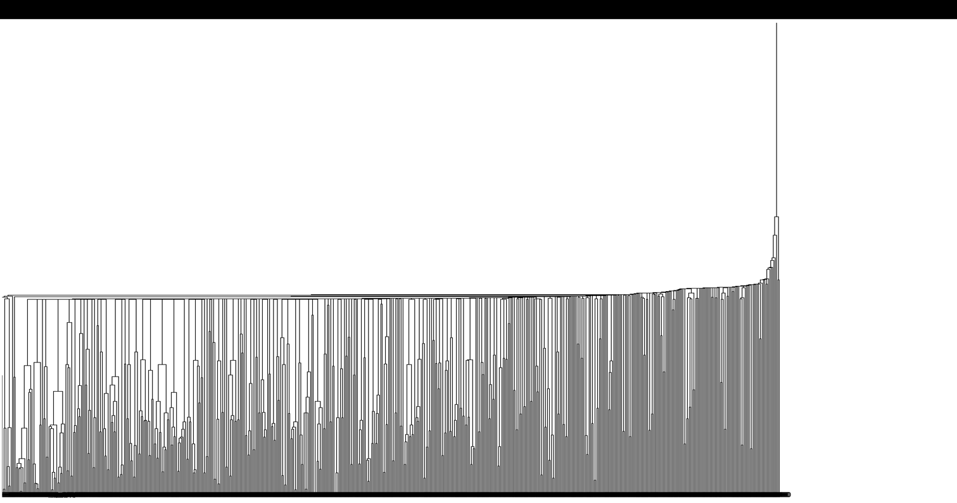

**Hierarchical clustering for complete link**

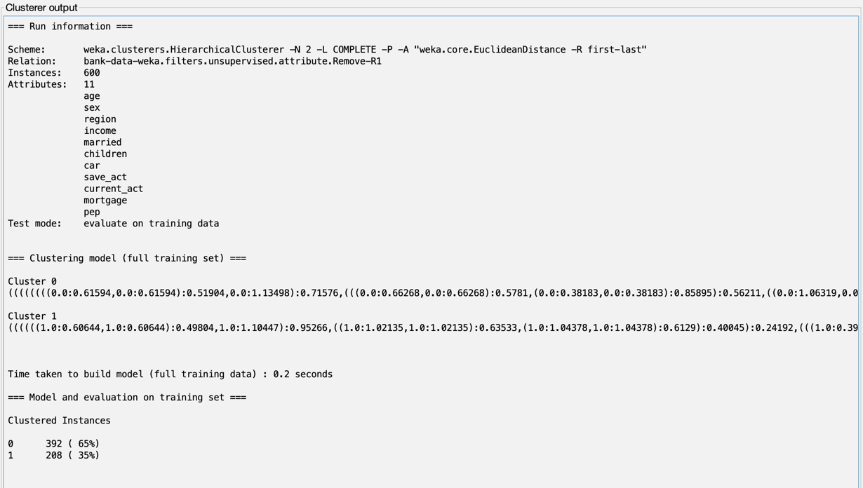

**Tree of Hierarchical clustering for complete link**

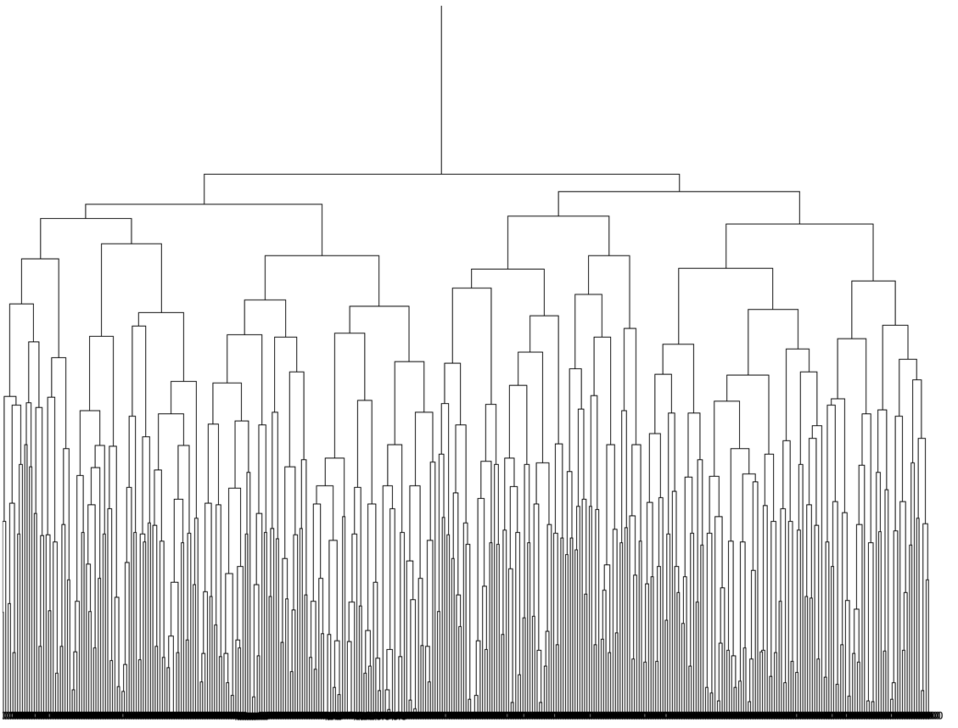

**K-means clustering for Euclidean distance metric**

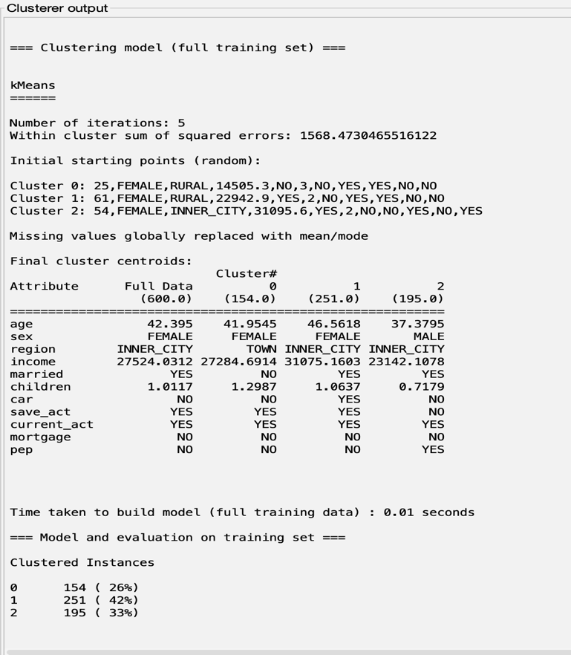

**Cluster Assignments for K-means clustering for Euclidean distance metric**

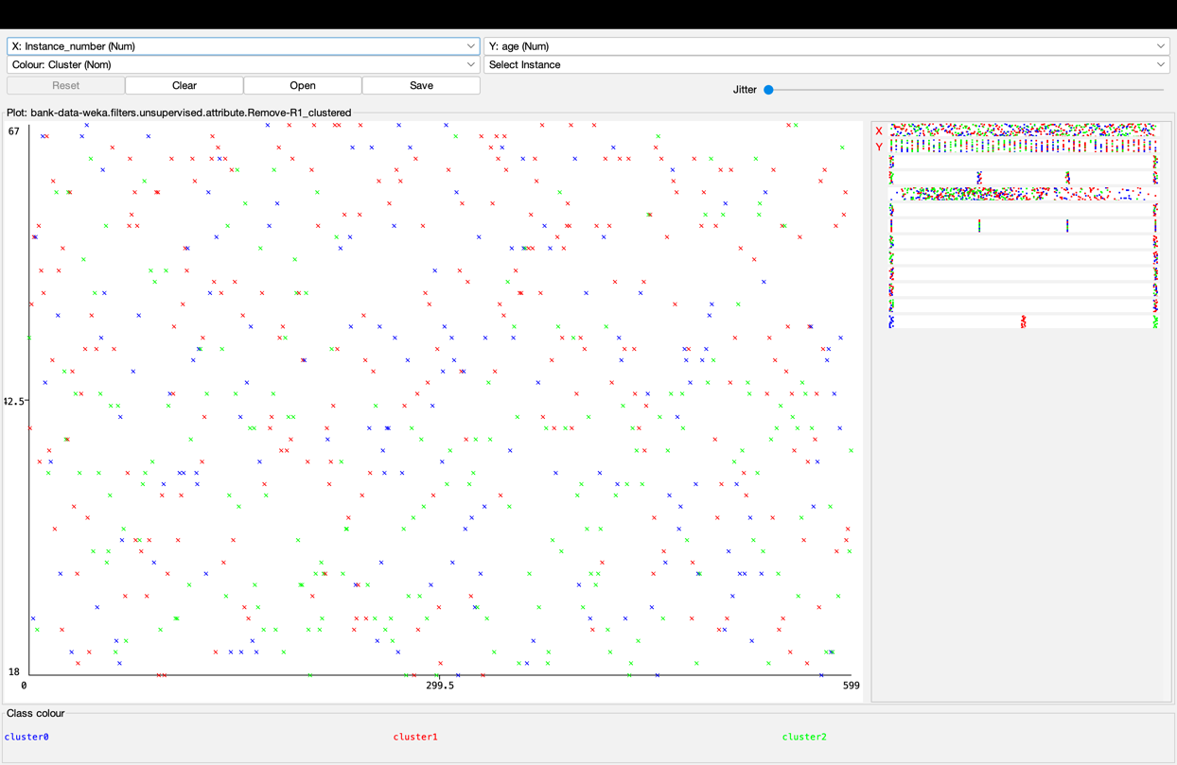

**K-means clustering for Manhattan distance metric**

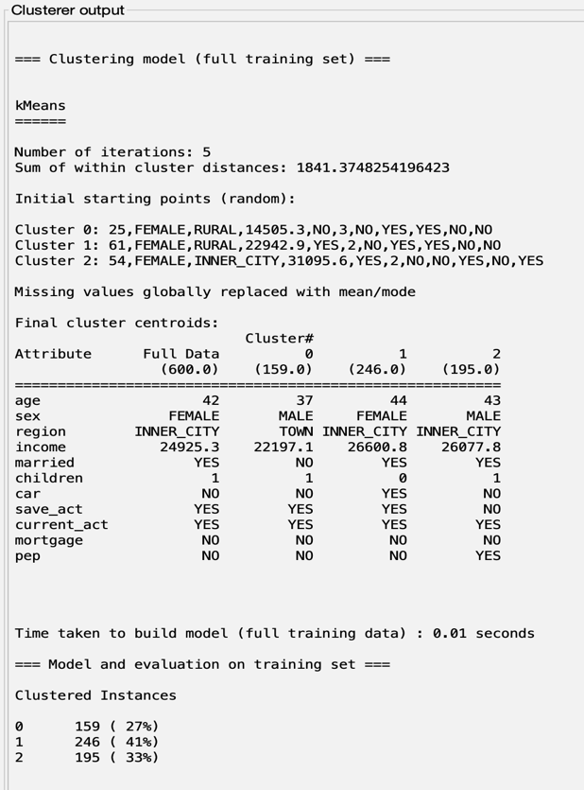

**Cluster Assignments for K-means clustering for Manhattan distance metric**

